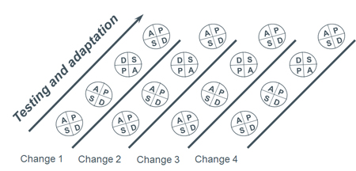
PDSA Tracker Worksheet: Use with each change you are testing

Project Title: | Aim Statement:

 | PLAN |  |  |  | DO | STUDY | ACT
PDSA Cycle No. | What change are you testing? | What have you learned from previous PDSAs? | What do you predict will happen? | What data will you collect to know how it’s working? | Describe what happened. | What did you learn? | What will you do next? (Adapt, Adopt or Abandon)
1
2
3
4
5
6
7
8
9
10

